**DBMS LAB WEEK – 5**

**NAME:** DIVYANSHU SHARMA

**SRN:** PES1UG20CS806

**SECTION:** D

**SEMESTER:** 5TH

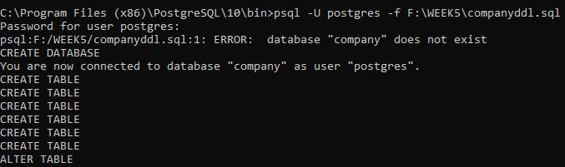C**reating “company” database and importing companyddl.sql file:**

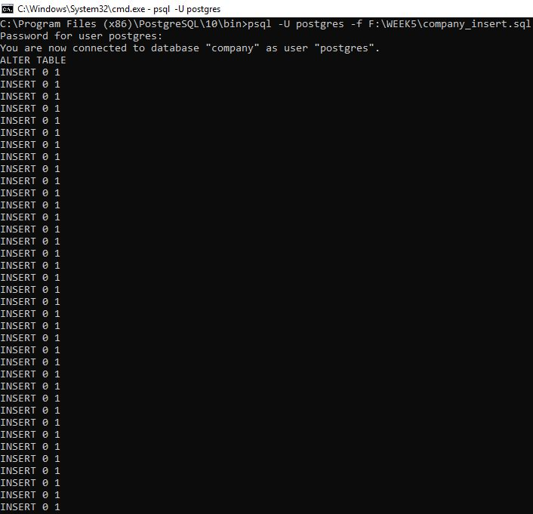**Inserting company_insert.sql file:**

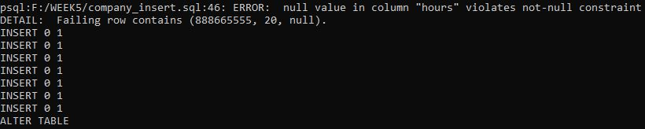

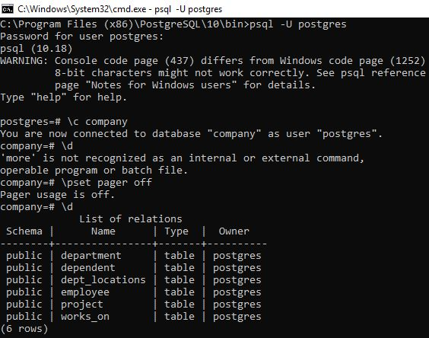**Now connecting to Company Database:**

1. **SQL DML**

* 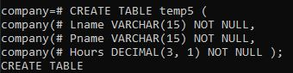**Create a temporary table that has the employee last name, project name, and hours per week for each employee working on a project. Insert the values into the table using insert into with select command**.

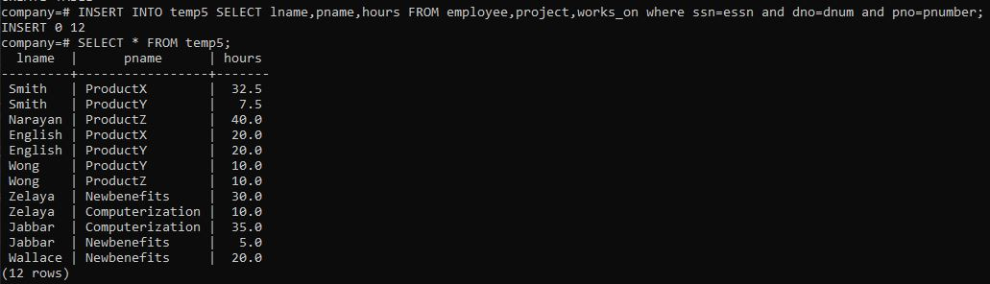

* 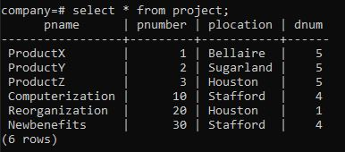**Update the location and controlling department number of project number 10 to ‘Bellaire’ and 5, respectively**.

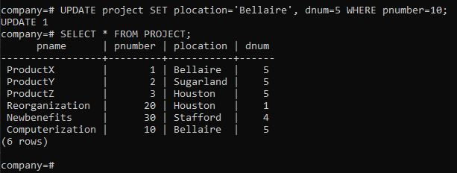

* 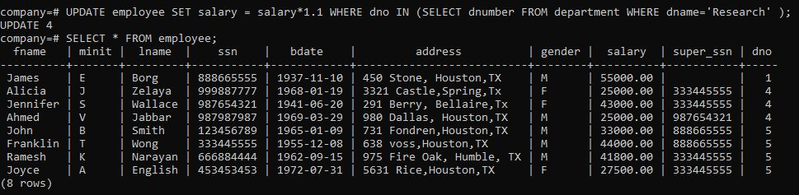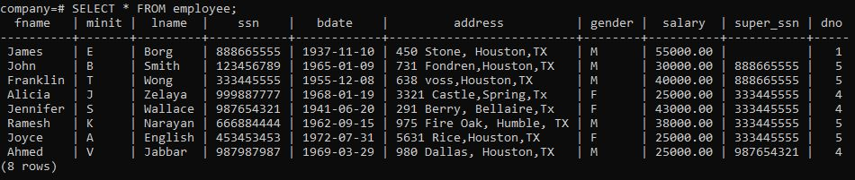**Give all employees in the ‘Research’ department a 10% raise in salary.**
* **Delete employee record whose lname =’Brown’**

As there are no lname with “brown”. Therefore, there will be no alteration in Employee Table

* **Delete all the records of the employee who doesn’t have dependent. (use sub query).**

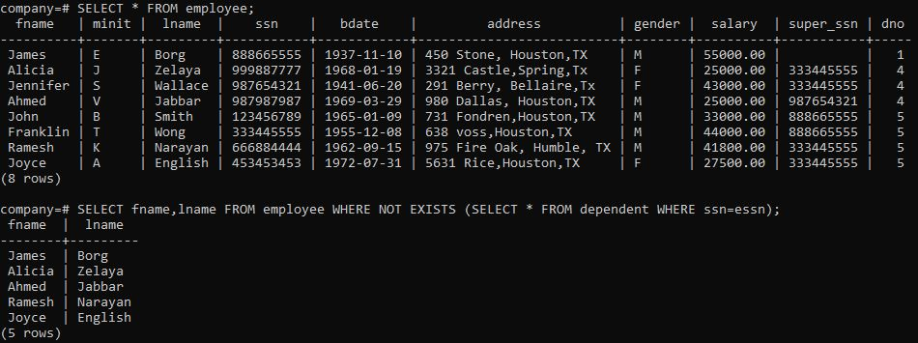There are total of 5 records who doesn’t have Dependent.





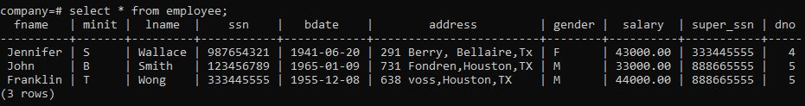

1. **Transactions: Create a transaction using begin and end commands consisting of the following sql statements.**

* **Create a transaction consisting of a create table and multiple insert statements. After End transaction the changes should be committed and can be checked using select statement.**

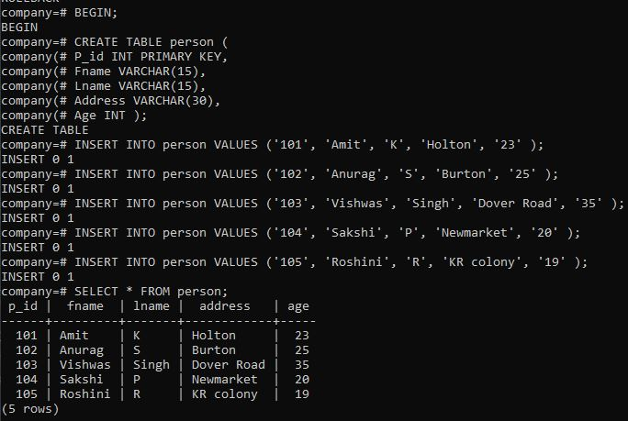

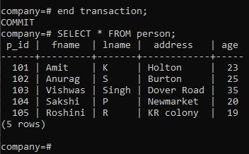

* 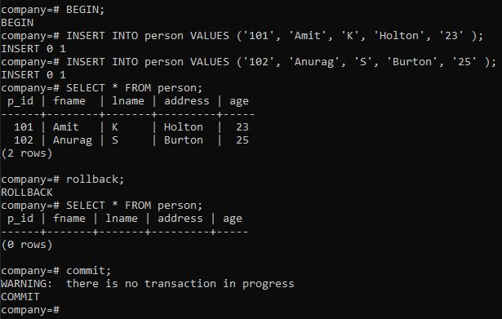**For the above transaction introduce a roll back after inserting 2 records. The create and insert should not be reflected in the database.**
* 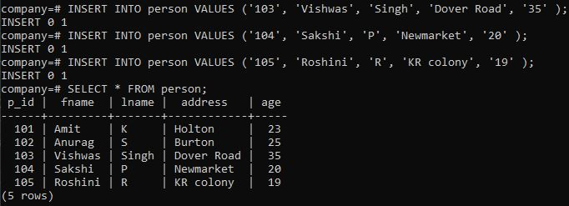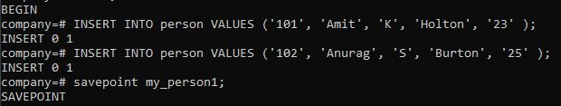**For the first transaction introduce a save point after inserting 2 records and insert 2 more records and rollback to savepoint. They database should reflect only first 2 insert**.

